* 1. Set Up and Create a Git Repository



**Step 1.1.1:** Downloading Git from the official site for your operating system.

Git is already installed in your practice lab. (Refer QA to QE: Lab Guide - Phase 1)

Open your Chrome browser and navigate to <https://git-scm.com/downloads> page of Git. Click on the **Download <Version_Number> for Windows** button available on the right side of the screen as shown in the screenshot below:

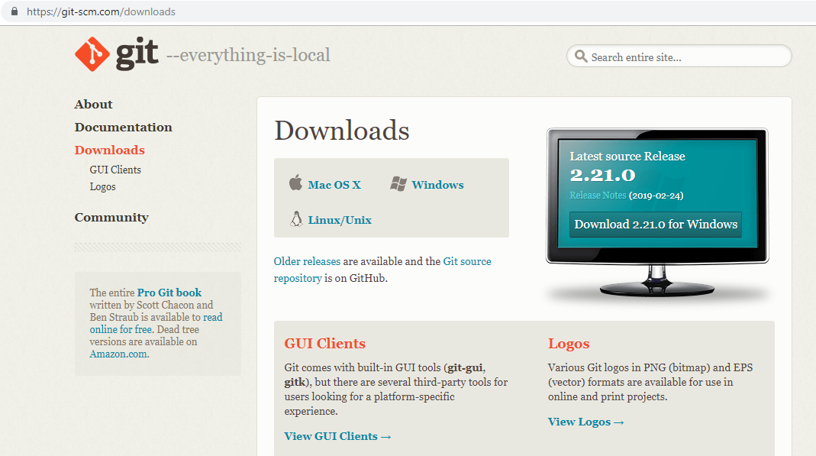

**Step 1.1.2:** Configuring Git in your system.

* Locate the downloaded git.exe file
* [right-click] on the executable git file and select **Run as administrator**
* Once you accept the installation request, you will be directed to the **Information** window. Click on **[Next >]** button.
* Do not make any changes and click on **[Next >]** button.
* You will be prompted to select the default editor used by Git. Select **Use Vim (the ubiquitous text editor) as Git’s default editor** and click on **[Next >]** button.
* You will be prompted to select how to use Git. Select **Git from the command line and also from third-party software** and click on **[Next >]** button.
* You will be prompted to select the HTTPS transport backend. Select **Use the OpenSSL library** and click on **[Next >]** button.
* You will be prompted to select a style to treat the line endings in text files. Read the options and select one per your preference. Click on **[Next >]** button.
* You will be prompted to select the terminal emulator. Read the options and select as per your preference. Click on **[Next >]** button.
* You will be prompted to choose the features to enable. Do not make any changes and click on **[Install]** button.

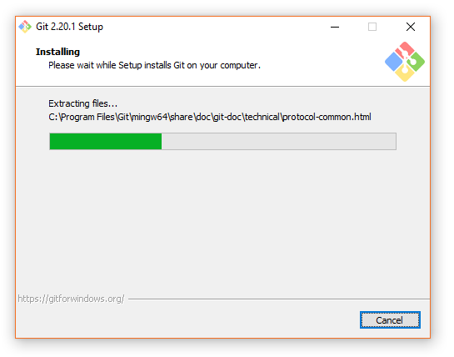

**Step 1.1.3:** Generating files and initializing the .git directory.

* Create a folder on your desktop and open it.
* Create the files: hello.js, index.html, and helloWorld.java.
* Open the Git terminal and navigate to the folder you have created.
* Execute the following command to initialize the .git repository:

git init

**Step 1.1.4:** Executing the basic commands.

* Add all the files to your git repository using the following command:

*git add*

* Commit the changes using the following command:

*git commit -m*

* 1. CRUD Operations in Git

1. Creating

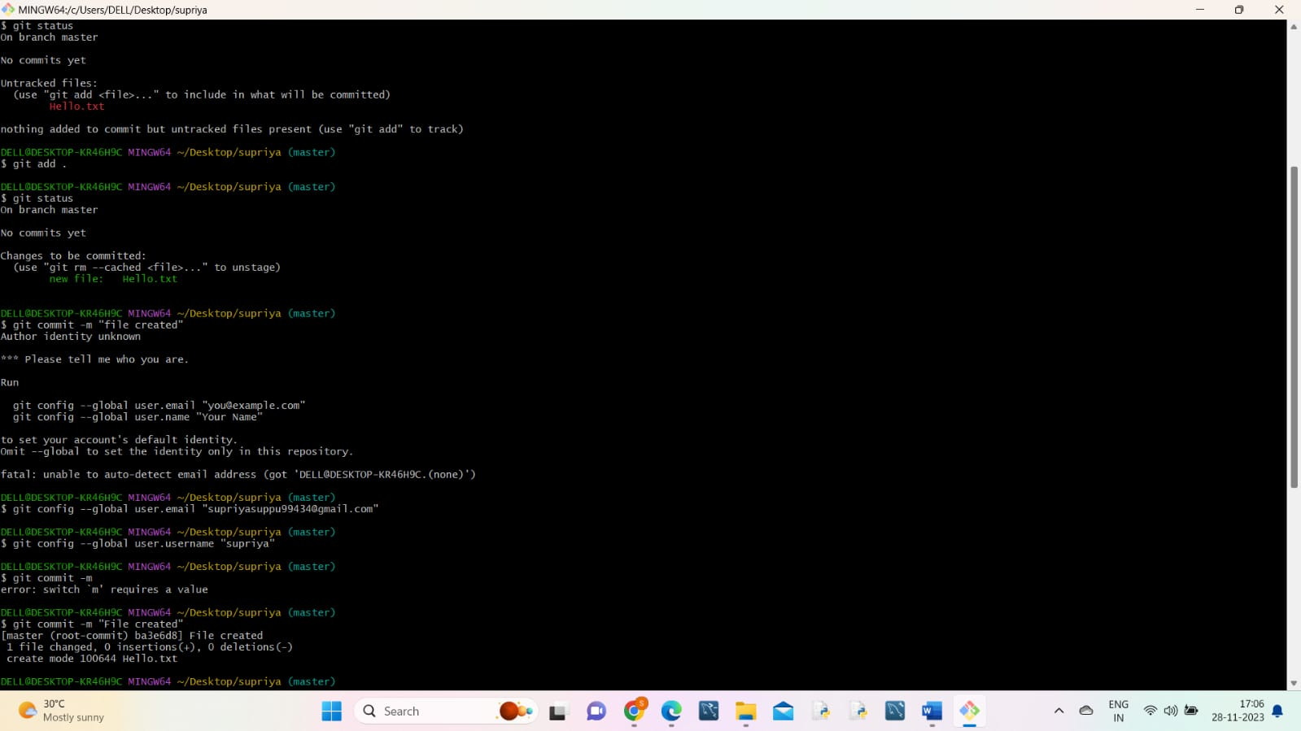

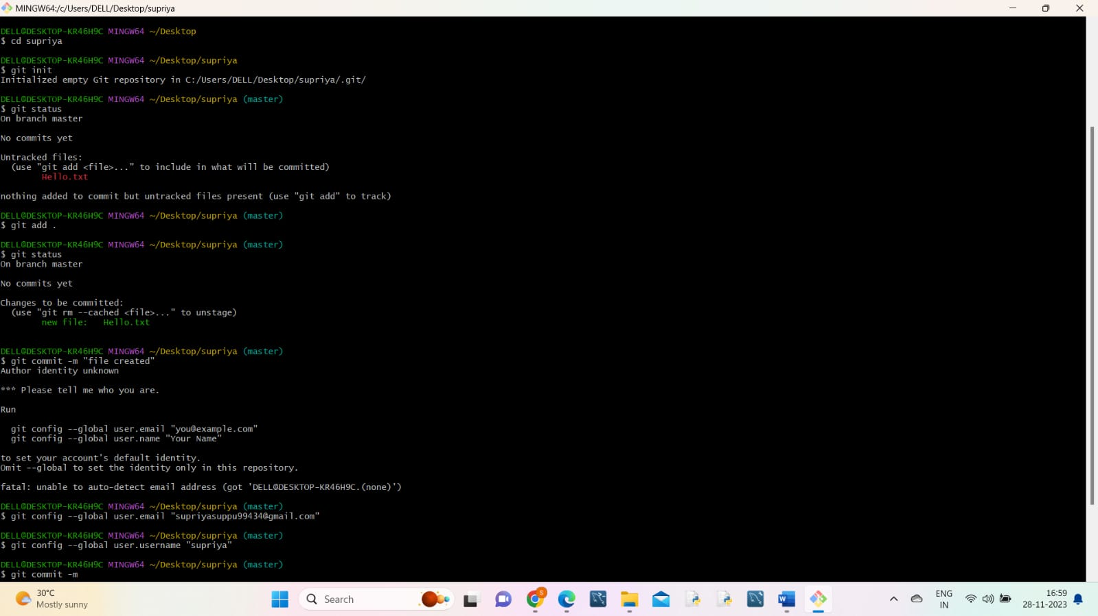

Commands used

Git status

Git add <file name>

Git commit -m “Message”

1. Read

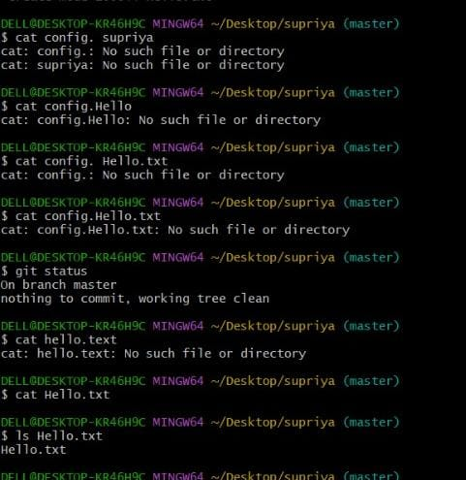

Commands used

Cat<filename>

Ls <filename>

1. Update

Commands used

nano <filename>

(do all the changes then use ctrl+ o to write out and ctrl + x to exit)

Git commit -m “message”

1. Delete

Commands used

Rm <filename>

Git status

Git commit -m “message”

1.3 Set Up and Configure GitHub Account

**Step 1.3.1:** Setting up your GitHub account.

**About GitHub:** It is a web-based hosting service for version control using Git. It offers plans for public and private repositories. You can add multiple projects by creating multiple public repositories. In this section, we will only demonstrate how public repository works.

Navigate to https://github.com/ and click on **Sign up for GitHub**. Enter the details and click on **Create an account**.

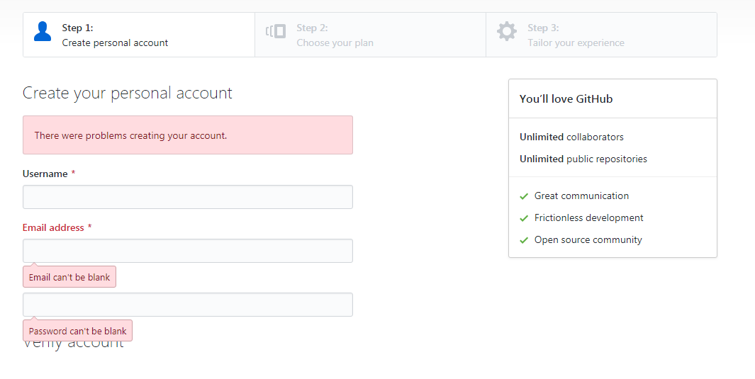

Once you’re at **Step 2: Choose your personal plan**, Select **Free,** and click on **Continue**. You can share basic information about yourself or you can select **skip this step**.

You must have received an email to confirm your account. It is important to confirm your account before you use GitHub. Once you have confirmed, you are successfully signed for GitHub.

**Step 1.3.2:** Creating an SSH Key and adding it to GitHub.

You can create ssh-key via **Git bash** by following the steps:

* Open your **Git bash**
* Execute the command:

ssh-keygen -t rsa -b 4096 -C “<your email address>” 🡪 press [enter]

* Do not enter anything but [enter] until the setup is complete
* Start the ssh-agent in the background:

eval $(ssh-agent -s)

* Add your SSH private key to the ssh-agent

ssh-add ~/.ssh/id_rsa

* Copy the SSH key to your clipboard

clip < ~/.ssh/id_rsa.pub

* Copy the entire key from the clipboard. Choose ***Your avatar* > settings** > **SSH & GPG Keys** and click on **New SSH** **key** and paste the key and **save** it

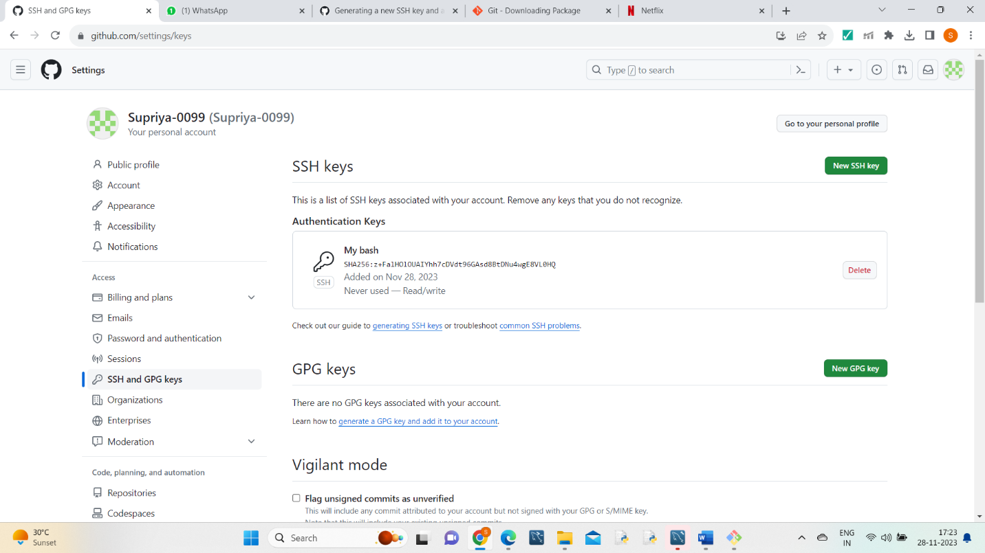

**Step 1.3.3:** Logging at local Git to connect with remote GitHub.

Open the Git terminal and execute the commands below by replacing **your_Email_Id** with your registered email address with GitHub and replace **Your_Username** with your GitHub username.

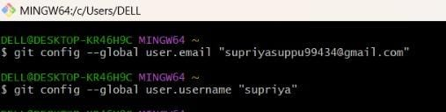

**Step 1.3.4:** Creating a repository in your GitHub account.

Go to the homepage of GitHub.com and click on **New Repository** as shown below:

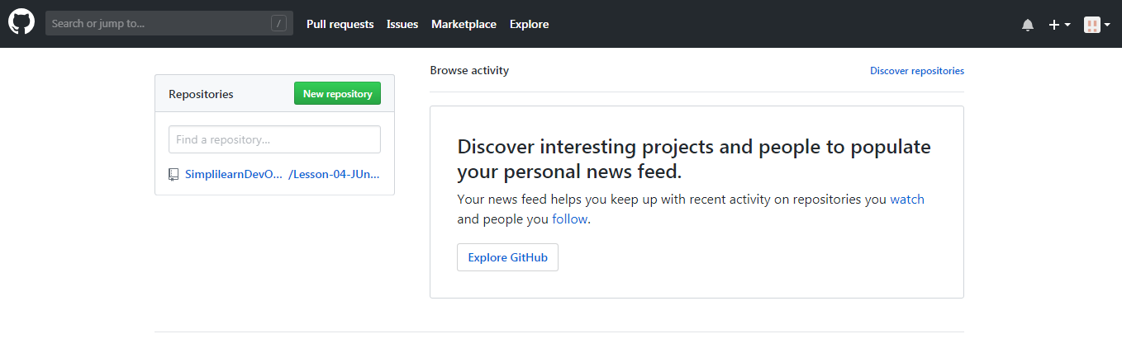

Enter the name file and click on **Create repository** as shown in the example screenshot mentioned below:

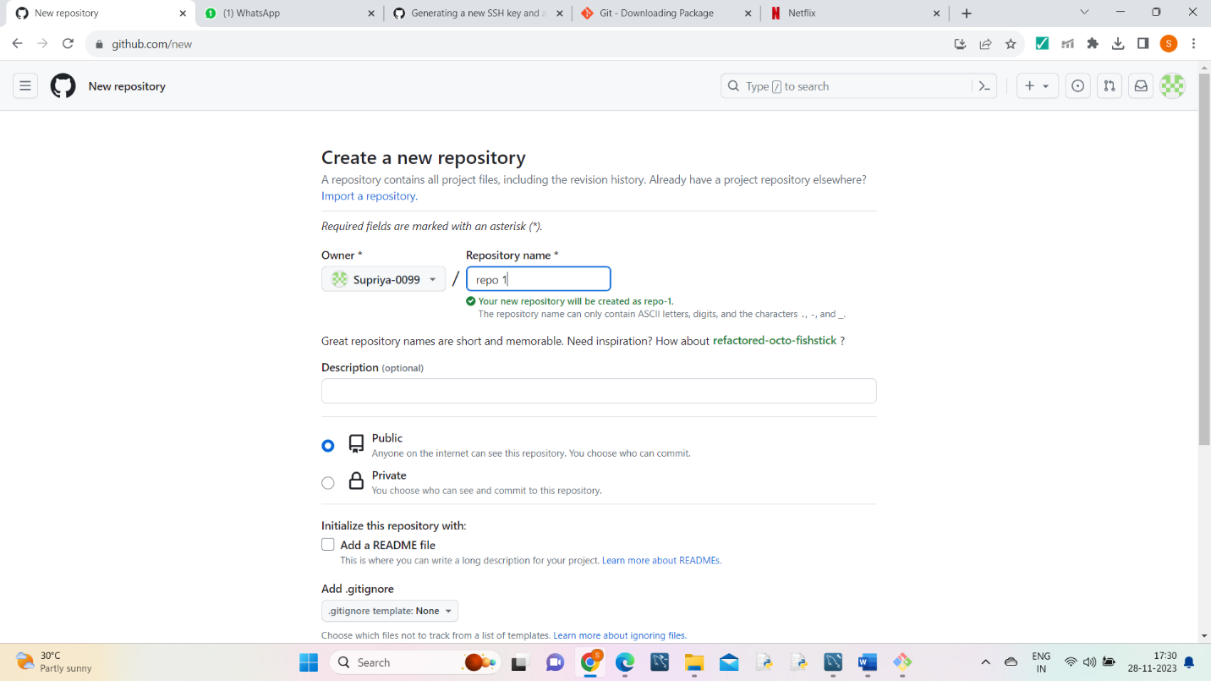

You will be redirected to a quick guide page and inside the directory you have created.